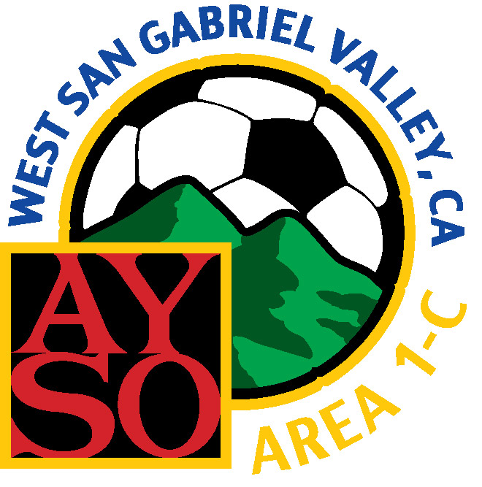

Area 1C
Temporary Coach Authorization

__________________________________ (name) is hereby authorized to act as the head Coach of the Under____ Girls/Boys team from Region ________ for the game scheduled to be held on ________________________________ (date) at ________ (time) on the following field: ________________________________. He/she is responsible for understanding the AYSO Area 1C Under-19 and Under-16 Upper Division Rules and Regulations and agrees to abide by them, as well as the terms of the Coach’s Application in the form attached to such Rules and Regulations.

Date: _______________________ ________________________________________ Regional Commissioner, Region _____

Date: _______________________ ________________________________________ Area Director or Area Program Coordinator

This temporary coach authorization MUST be presented to the referee prior to the start of the game and shall be valid only for the game designated.

